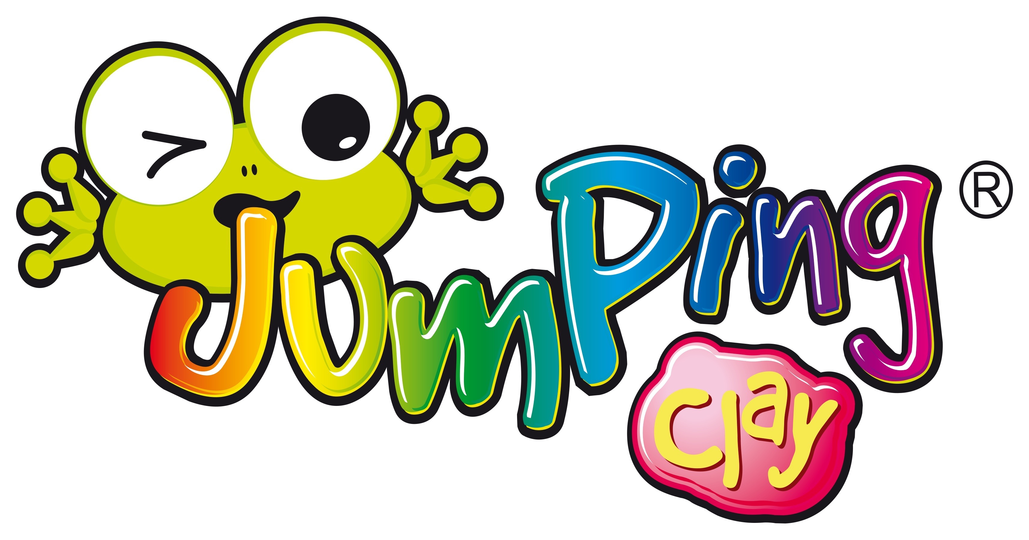
Start a creative adventure into the magical world of 3D educational fun!
Jumping Clay is pleased to be offering another term of our fun and creative after-school club on Thursdays for the pupils of Melbourne Infant School.
Beginners are warmly welcomed.
The programme will engage children in the wonders of colour and shape, helping them to develop observation skills, creative thinking, spatial awareness, fine tune their motor skills and stimulate their senses all whilst having FUN!
The courses will be conducted in one hour structured lessons by qualified instructors and is suitable for children in Reception, Year 1 and 2.

This course is available on Thursdays for 10 sessions and costs £52.50.

Thursday 15:30-16:30
(parent transfer between school and after school session not required)
Week 1 | 2nd May | Food Glorious Food  Historical Anniversaries – e.g. 50 years since the moon landing.
Week 2 | 9th May
Week 3 | 16th May
Week 4 | 23rd May
Half Term
Week 5 | 6th June
Week 6 | 13th June
Week 7 | 20th June
Week 8 | 27th June
Week 9 | 4th July
Week 10 | 11th July

How to Book:
By text – text your child’s name and school to 07805 306625.
Online booking and payment system - To access the booking system, go to www.jumpingclay.co.uk, click on the book now button, search for local courses based on your postcode and click on Melbourne Infant School After School Club and follow the on-screen instructions.
Places are subject to availability and are issued on a first come basis. Please text or email us if you would like to set up a password system to enable other people (not just the “parent” registered on our system) to collect your child.
www.jumpingclay.co.uk/Derby, facebook - jumpingclayderby, twitter - jumpingclay Derby
Unit D Markeaton Craft Village, Markeaton Park, Derby, DE22 3BG
Holiday Time Sessions – from 1 hour to the whole day
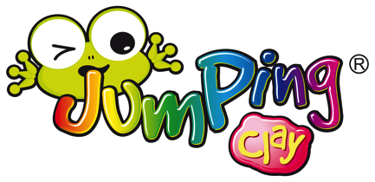
BUILDS YOUR CHILD’S CONFIDENCE
We provide a fun and structured nurturing environment. Our lessons engage children in the wonders of colour and shape, helping them to build their confidence, fine tune their motor skills and stimulate their senses all whilst having lots of FUN. We love to see the big, wide, smiles on the children’s faces when their model is finished.

ENCOURAGE AND PRAISE
Children’s imaginations are so great that sometimes the model looks quite different to them to how it looks to us adults. With encouragement and praise their model making skills will improve. As children become more self critical, as they mature, then their model making skills will improve significantly.
PRACTISE MAKES PERFECT
We really want every child to take home a model they love and are proud of. We will help children by showing them but we try very hard not to actually do their model for them. When they do it themselves it builds their confidence and improves their skill levels. Just like learning any new skill it may take practice to master it.
HELPS YOUR CHILD DEVELOP PROBLEM SOLVING SKILLS
Using Jumping Clay has been shown to help the ‘right side’ brain development which in turn helps develop creative thinking, spatial awareness and problem solving skills - important skills for life in general and great for subjects like Maths and Science.
Why clubs are great

WHY ARE FINE MOTOR SKILLS IMPORTANT?
Fine motor skills refers to the small movements linked to the development of the many small muscles in the hands and fingers. Poor fine motor skills can make everyday tasks difficult, which can affect a child’s self esteem and their academic performance can be compromised.
Strong and dexterous hands/fingers make handwriting easier, neater and quicker. Other benefits are making buttons, zips and using cutlery easier too.
Jumping Clay and its elastic texture is the perfect resistance material to quickly build strength and dexterity in hands and fingers.
.

