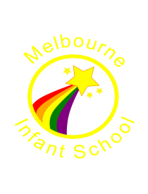

**Your Child’s Learning:**

In English this half term the children will be learning to:

* Read and write instructions.
* Write a sentence with a capital letter, finger spaces and full stop.
* Developing story writing skills such as: retelling a story, acting out a story and expressing views about a story.

In maths this half term the children will be learning to:

* Represent and use number

bonds and related subtraction

facts within 10. (2+4=6, 4+2=6, 6-4=2, 6-4=2)

* Count in 1’s forwards and backwards from any number to 100.
* Recognise 2D shapes (circle, triangle, square, pentagon, hexagon, rectangle, and octagon).
* Form numbers correctly (1-9).

Additionally, during the half term your child needs to choose and complete at least 2 of the following tasks. These can be brought into school during the half term..

Autumn 2 2017

Blue Learning Team: Year 1

**English**

**Write a set of instructions for making a food or drink item of your choice.**

**Maths**

**The answer is 20. What could the question be? How many possibilities are there? How can you show us the answer?**

**Materials**

**Could we live in a house made of sweets?**

**Science**

**Design a poster using these headings: Paper, Glass, Wood, Concrete, Metal, Plastic. Can you give examples for each one? Can you describe their properties?**

**Art/ Design and Technology**

**Can you design / make a strong and sturdy house for Hansel and Gretel to live in.**

Ressing views